### *Power BI Inflation Analysis: Journeying Through Global Economic Terrain*

Inflation, a critical economic indicator, profoundly impacts businesses, consumers, and policymakers worldwide. In this scenario, a multinational corporation operating in diverse markets seeks to optimize pricing strategies, mitigate risks, and make informed investment decisions. Leveraging Power BI's analytical prowess, we delve into inflation data to offer tailored recommendations aligned with each market's unique economic conditions.  
  
Our approach involves data collection, preparation, and modeling to build a robust analysis framework. Through insightful visualizations and strategic recommendations, we aim to equip stakeholders with actionable insights for informed decision-making. Our deliverables include an interactive Power BI dashboard showcasing inflation trends and a comprehensive report summarizing analysis findings and recommendations.  
  
***Scenario 1:*** Lack of Data Integration and Standardization  
In the context of "Power BI Inflation Analysis: Journeying Through Global Economic Terrain," a key problem might be the lack of standardized data sources and integration methods. Different regions and organizations may report inflation data differently, leading to inconsistencies and challenges in aggregating and analyzing global inflation trends effectively within Power BI. This lack of standardization hampers the ability to provide accurate and comprehensive insights into inflation dynamics worldwide.  
  
***Scenario 2:*** Limited Historical Data Accessibility   
Another challenge could be the limited accessibility to historical inflation data across various countries and regions. This scarcity of historical data poses a significant obstacle in building robust predictive models within Power BI for forecasting inflation trends accurately. Without a comprehensive historical dataset, analysts may struggle to identify long-term patterns and correlations necessary for making informed decisions and projections.  
  
***Scenario 3:*** Complex Economic Interdependencies   
The intricate interdependencies among global economies pose a complex challenge in "Power BI Inflation Analysis: Journeying Through Global Economic Terrain." Fluctuations in one country's inflation rate can have ripple effects across other regions, making it difficult to isolate and analyze the drivers of inflation within individual economies. Effectively capturing and analyzing these interdependencies within Power BI requires sophisticated modeling techniques and access to diverse datasets, which may not be readily available or easily integrated into the analysis platform.

***Technical Architecture:***

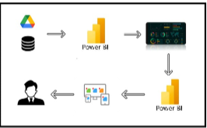

***Project Flow:`***

To accomplish this, we have to complete all the activities listed below,  
1)   Data Collection  
o    Collect the dataset,  
o    Connect Data with Power BI  
2)       Data Preparation  
o    Prepare the Data for Visualization

3)        Data Visualizations  
o    Visualizations  
4)      Dashboard  
o    Responsive and Design of Dashboard  
5)        Report  
o   Report Creation  
6)        Performance Testing  
o    Amount of Data Rendered to DB  
o    Utilization of Data Filters  
o    No. of Calculation fields  
o    No. of Visualizations/Graphs  
7)     Project Demonstration & Documentation  
o    Record explanation Video for project end to end solution  
o    Project Documentation-Step by step project development procedure

***Data Flow:***

***Milestone-1: Data collection & Extraction from database.***

Data collection is the process of gathering and measuring information on variables of interest, in an established systematic fashion that enables one to answer stated research questions, test hypotheses, evaluate outcomes and generate insights from the data.

***Activity 1.1: understanding the data:***

Data contains all the meta information regarding the columns described in the CSV files.

***Dataset link:*** <https://www.kaggle.com/datasets/sazidthe1/global-inflation-data>

***Column Description of the Dataset:***

1. Country_name: Name of the Country.
2. indicator_name: Type of inflation indicator.
3. Year : Year of the inflation.
4. Inflation_rate:  Average Inflation Rate.

***Milestone-2: Data Preparation.***

Data preparation is a critical stage in the data analysis process, encompassing activities aimed at cleaning, transforming, and organizing raw data into a structured format suitable for analysis. This process involves identifying and addressing issues such as missing values, outliers, inconsistencies, and inaccuracies in the dataset, ensuring data quality and reliability.

***Activity-1: Preparation the data for visualizations:***

Preparing the data for visualization involves cleaning the data to remove irrelevant or missing data, transforming the data into a format that can be easily visualized, exploring the data to identify patterns and trends, filtering the data to focus on specific subsets of data, preparing the data for visualization software, and ensuring the data is accurate and complete. This process helps to make the data easily understandable and ready for creating visualizations to gain insights into the performance and efficiency. Since the data is already cleaned, we can move to visualization***.***

**Data Loading:** <https://drive.google.com/file/d/1JMjR4fSZBcwvlb_fxA7BnGbaShkfmKFC/view?usp=drive_link>  
  
**Data Cleaning:**<https://drive.google.com/file/d/1D0oNnWfUduM-vVHNTeElYErzsYsgIrK7/view?usp=drive_link>

To prepare data for visualizations in Power BI, specifically for inflation analysis across countries and years, followed these steps:

**1. Import Data into Power BI**

* **File**: Imported global inflation data from an CSV or database file into Power BI.
  + Go to **Home** > **Get Data** > Choose file format (e.g. CSV).
  + Load the data into Power BI.

**2. Clean the Data (Remove Nulls, Duplicate Data)**

* Go to **Transform Data** (Power Query Editor) to clean the data.
* **Remove Nulls**: Select columns with inflation rates and filter out null values.
  + In Power Query, select the column > Click on the **Filter** icon > Uncheck **null** to remove them.
* **Remove Duplicates**: If there are duplicate rows, remove them by:
  + Go to **Transform** > **Remove Duplicates**.
* **Rename Columns**: Ensure column names are consistent and clear (e.g., country_name, indicator_name, year, inflation_rate).
* **Change Data Types**:
  + Ensure that columns like Year are formatted as **Whole Numbers** and Inflation_rate is formatted as a **Decimal**.
  + Done this in Power Query or directly in Power BI by selecting the column in the Data View and changed the data type.

**3. Unpivot Year Columns :**

The data has inflation rates spread across multiple year columns (e.g., 1980, 1981, 1982), should **unpivot** these columns so that each year and inflation rate appear as separate rows. This will allow better flexibility in visualizations (like heatmaps, line charts, etc.).

* In **Power Query Editor**, selected all year columns (1980, 1981, etc.).
* Right-click and choose **Unpivot Columns**.
* Renamed the generated column (usually Attribute) to Year and the other one (usually Value) to Inflation_rate.**4. Create Calculated Columns/Measures:**

For more advanced analysis, such as comparing inflation rates across years or calculating Year over year changes, created calculated columns or measures using DAX. The DAX measures like Average inflation rate, minimum inflation rate, maximum inflation rate, and target inflation rate.

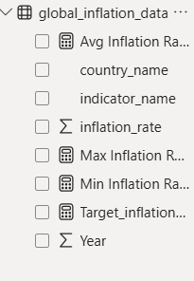

**5. Save Data Preparation Steps:**

Once cleaned, transformed, and unpivoted your data, click **Close & Apply** in the Power Query Editor to load changes into Power BI.

***Milestone-3: Data Visualization:***

Data visualization is the process of creating graphical representations of data to help people understand and explore the information. The goal of data visualization is to make complex data sets more accessible, intuitive, and easier to interpret. By using visual elements such as charts, graphs, and maps, data visualizations can help people quickly identify patterns, trends, and outliers in the data. Once data is ready, created a variety of data visualizations in Power BI to analyze inflation trends by country and year. Here are some visualizations are created:

**1. Line Chart: Global Inflation Trends:**

* **X-Axis**: Year
* **Y-Axis**: Inflation_rate
* **Legend**: Country_name
* **Purpose**: To analyze inflation trends over time for each country.

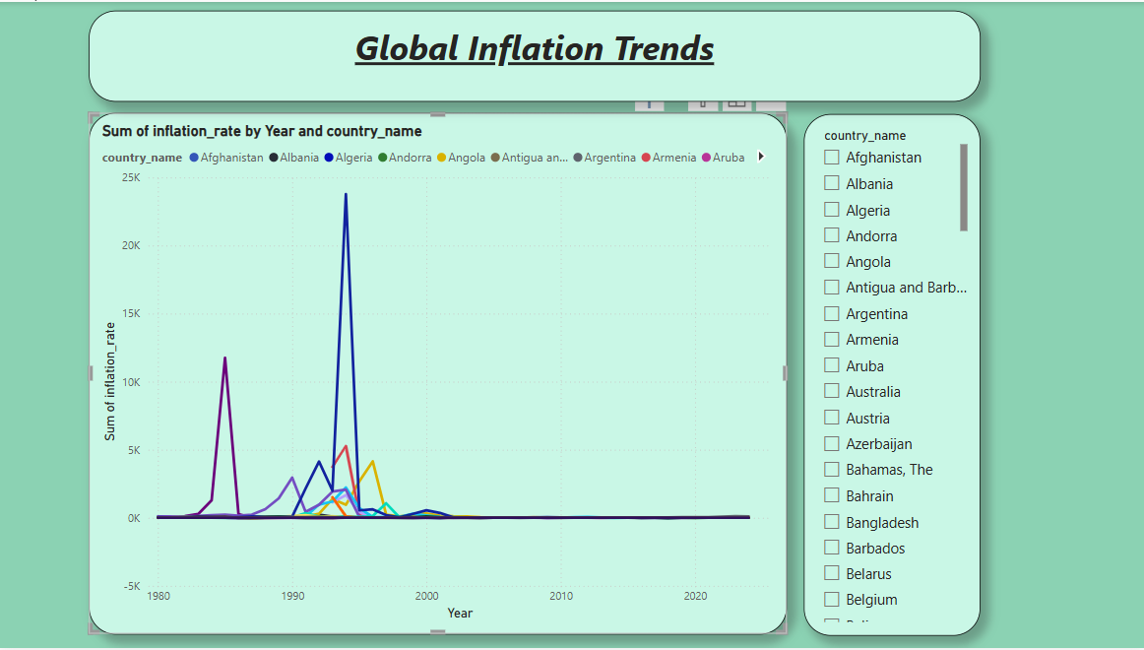

This visualization shows inflation trends across multiple years for different countries. Additionally added slicer to analyze the data easily.

**2. Stacked Bar Chart: Basic Inflation Rates by Year and Country:**

* **Purpose**: To compare the inflation rate between countries in specific years.
* **X-Axis**: Country_name
* **Y-Axis**: Inflation_rate
* **Legend**: Year

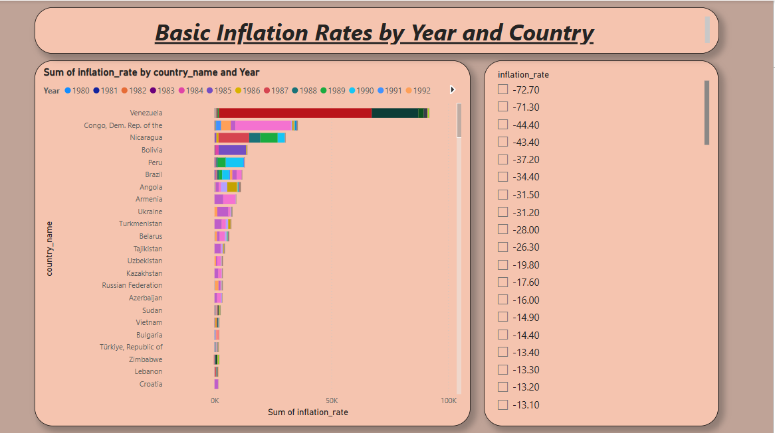

This allows to compare inflation rates between different countries for one or more selected years, with a focus on how different countries performed in certain years. Additionally added slicer to analyze the data easily.

**3.Matrix Table: Country-wise Inflation Data**:

* **Rows**: Country_name
* **Columns**: Year
* **Values**: Inflation_rate
* **Purpose**: To compare the inflation rate,country name and year in a tabular format.

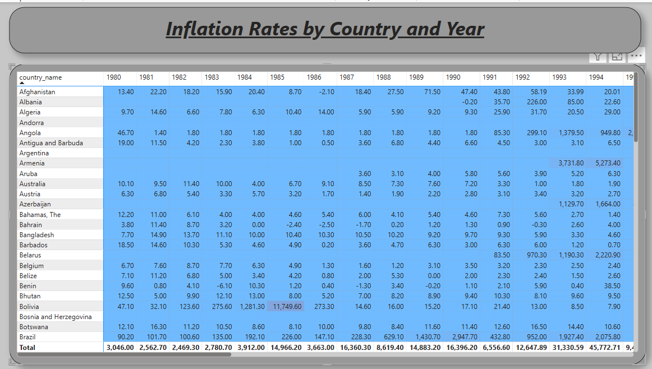

This visualization shows inflation trends across multiple years for different countries.

**4. Pie Chart: Inflation Rate Distribution per Year:**

* **Purpose**: To understand the share of inflation for each country in a particular year.
* **Values**: Inflation_rate
* **Legend**: Country_name

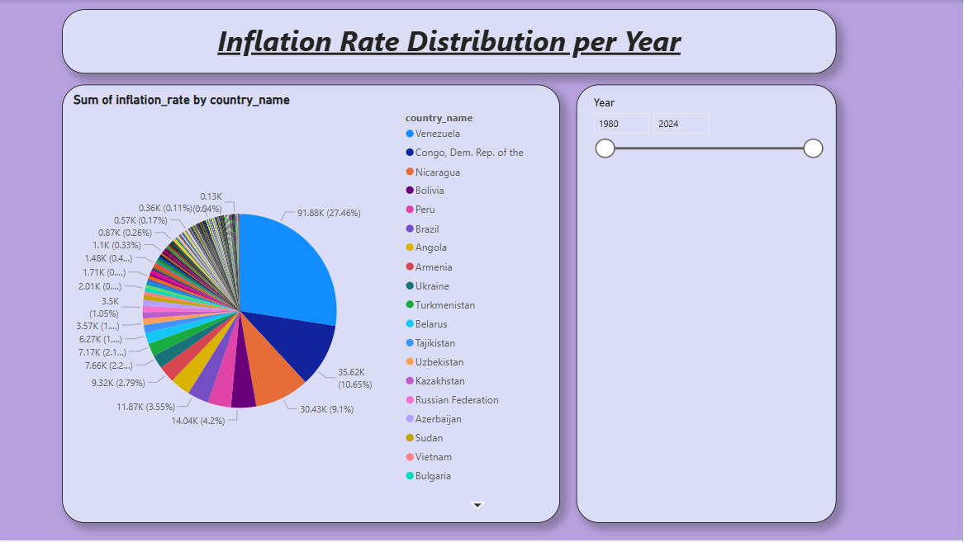

This chart is ideal for visualizing which countries have the highest and lowest shares of inflation in a given year. Additionally added slicer to analyze the data easily.

**5. Area Chart: Cumulative Inflation Trends by Country:**

* **Purpose**: To observe cumulative inflation trends for each country over time.
* **X-Axis**: Year
* **Y-Axis**: Inflation_rate
* **Legend**: Country_name

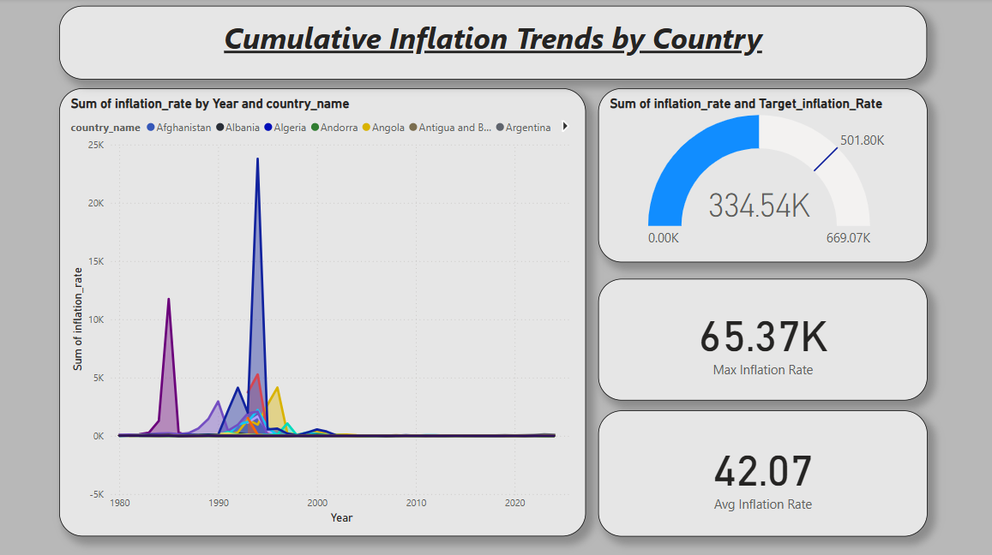

An area chart helps visualize the growth or decline in inflation over time, highlighting which countries have consistent increases in inflation.

**6. Treemap: Inflation Rates Across Countries:**

* **Purpose**: To compare inflation rates across countries in a visual hierarchy.
* **Group**: Country_name
* **Values**: Inflation_rate

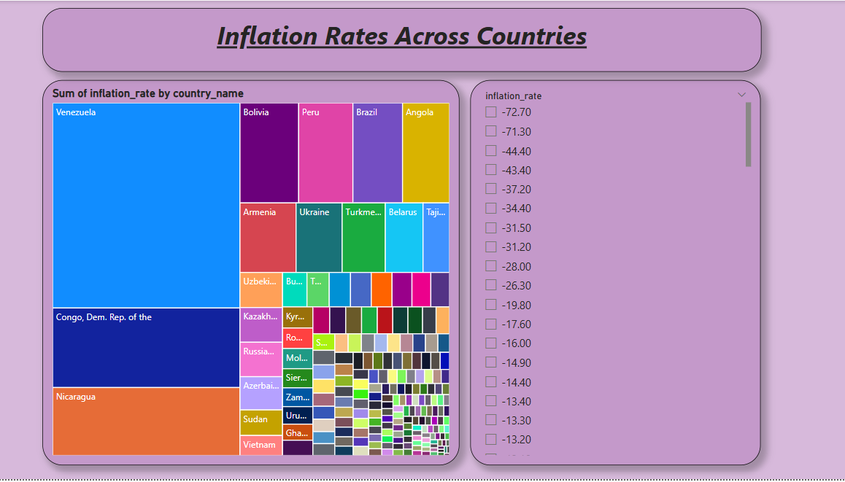

This visualization is useful for visually identifying the relative size of inflation rates across countries in a hierarchical format.

**7. Decomposition Tree: Analyzing Factors Affecting Inflation:**

* **Purpose**: To explore the factors affecting inflation rates and decompose by different dimensions such as Country_name, Year, and more.
* **Analyze**: Inflation_rate
* **Explain by**: Country_name, Year

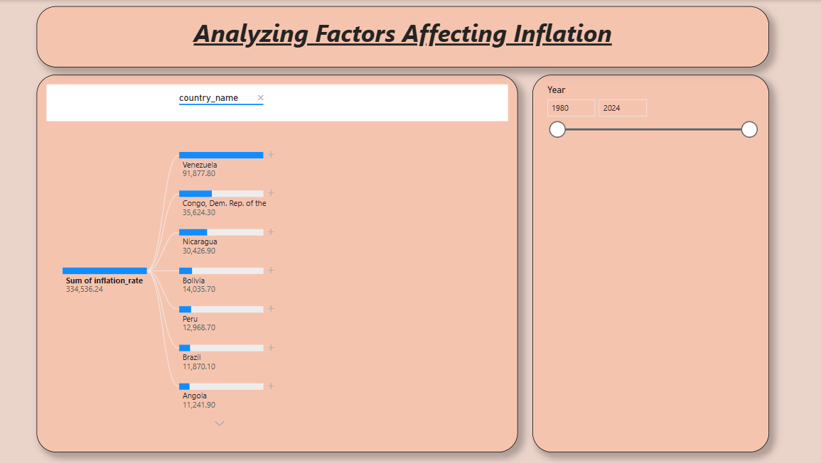

The Decomposition Tree is an AI-driven visual that helps you analyze how various factors contribute to inflation rates.

**8.** **Gauge: Sum of inflation rate by target value:**

* **Values**: Inflation_rate
* **Target Value:** Target_inflation_rate

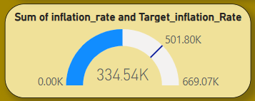

A visualization is ideal for tracking the performance of a single measure against a target value.

**9.Cards: Min, Max, Avg inflation rate:**

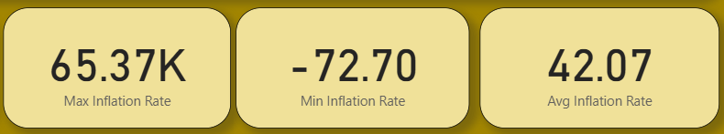

A **Card** visualization is great for displaying a single value, such as the inflation rate like Maximum iflation rate, minimum inflation rate, average infalation rate.

**10.Filled Map: Analyzing map by country_name and Inflation_rate:**

* **Location:** Country_name
* **Legend:** Inflation_rate

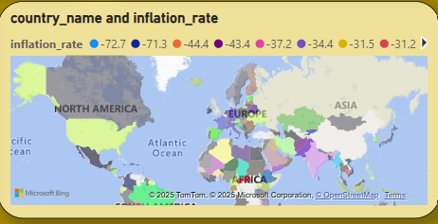

A **Filled Map** in Power BI is a great way to visualize geographical data, such as inflation rates across different countries.

***Milestone-4: DashBoard***

A dashboard is a graphical user interface (GUI) that displays information and data in an organized, easy-to-read format. Dashboards are often used to provide real-time monitoring and analysis of data and are typically designed for a specific purpose or use case. Dashboards can be used in a variety of settings, such as business, finance, manufacturing, healthcare, and many other industries. They can be used to track key performance indicators (KPIs), monitor performance metrics, and display data in the form of charts, graphs, and tables.

***Activity-1: Responsive and Design of Dashboard:***

Created a responsive and well-designed dashboard in Power BI is key to effectively communicating of data insights***.***

***Explanation video link:***<https://drive.google.com/file/d/1v2m9eFcbaSJk92iyFY1V8GrfYMBRA-2N/view?usp=drive_link>

**1. Define Key Metrics and Focus Areas:**

* Identify the most important data points for global inflation analysis, key metrics might include:
  + Year-over-Year Inflation Change.
  + Annual Inflation Rate per Country.
  + Inflation Trend by Year.
  + Regional Inflation Comparisons.
* Decide visualizations best represent these metrics (bar chart, gauge, card, filled map.).

**2. Choose the Right Visuals:**

* **Filled Map**: Use for country-level inflation rates. It provides a geographical overview of inflation across regions.
* **Bar Charts**: Great for Year-over-Year inflation comparisons across countries.
* **Heatmap**: Helps visualize inflation rates across multiple years, allowing you to compare countries and years.
* **Gauge**: Useful for showing target inflation rates versus actuals.
* **Card**: Show key performance indicators (KPIs), such as the average global inflation rate or highest inflation rate for a particular year.
* **Slicers**: Allow users to filter data by year, region, inflation indicator, or any other dimension.

**3. Design for Clarity and Simplicity:**

* **Balance Visuals**: Don’t overcrowd the dashboard with too many visuals. Focus on the most critical insights.
* **Use White Space**: Space between visuals is essential to avoid clutter and make your dashboard easy to read.
* **Consistent Colors**: Use a consistent color scheme. For example:
  + Use a range of green to red for inflation rates, where green represents low inflation and red represents high inflation.
* **Font Consistency**: Use consistent font sizes and styles across visuals. Larger fonts for headings and smaller fonts for details.
* **Labels and Titles**: Ensure all visuals have clear titles, axis labels, and tooltips to guide users through the dashboard.

**4. Final Touches:**

* **Interactive Elements**: Use buttons, bookmarks, and custom visuals to enhance the user experience.
* ***Theme: Apply a consistent theme (color palette,*** fonts, etc.) for professionalism and clarity.
* **Annotations**: Consider adding small text boxes or annotations near key visuals to guide users through insights or to highlight important .

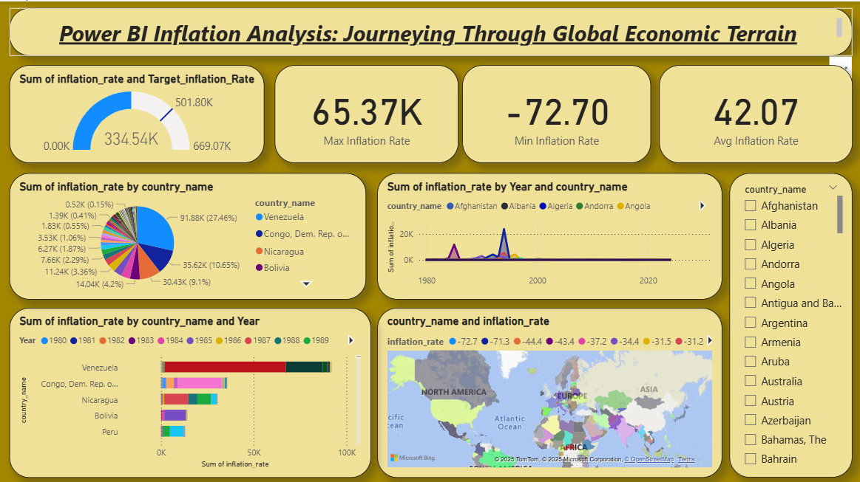

Created a professional, responsive, and well-designed Power BI dashboard that clearly communicates the inflation analysis insights.

***Milestone-5: Report***

A report is a comprehensive document that provides a detailed and structured account of data analysis, findings, and insights. It is typically used for in-depth analysis, documentation, and communication of results. Reports are suitable for a diverse audience, including decision-makers, analysts, and stakeholders who need a comprehensive understanding of the data.

***Activity-1: Design of report:***

Designing a report in Power BI involves connecting to data sources, creating visualizations like charts and graphs, customizing their appearance and interactivity, organizing them logically on the canvas, formatting elements for consistency and clarity, and optionally creating dashboards for a summarized view. Throughout the process, it's essential to consider the audience's needs and ensure the report effectively communicates insights from the data. Finally, iterate based on feedback to continually improve the report's design and usefulness.

***Explanation video link:*** <https://drive.google.com/file/d/1NdQopnklRDKJJJ7xuIsyQaQZxfe0b3vQ/view?usp=drive_link>

A well-designed report ensures that the data is easy to interpret and insights are quickly accessible. Below are the **steps, principles, and best practices** for created a professional and visually appealing report:

**1. Define the Report Objective:**

* Clearly understand the purpose of report. For the **Inflation Rates by Country and Year** report, the main objective is likely to:
  + Show inflation rate trends over time.
  + Compare inflation rates across different countries.
  + Highlight Year-over-Year changes.
  + Provide a geographical overview of inflation.

**2. Design of Key Visuals:**

Used the right visuals to convey the message efficiently:

* **Matrix**:
  + Show inflation rates across different countries using a Matrix. Countries with higher inflation rates can be colored darker (e.g., red), and countries with lower rates can be lighter (e.g., green).
  + **Rows**: Country
  + **Columns**: Year
  + **Values**: Sum of inflation_rate
* **Column Chart** :
  + Display inflation changes for each country, allowing users to track inflation fluctuations.
  + **X-Axis**: country_name
  + **Y-Axis**: Sum of inflation_rate
  + **Legend**: country_name
* **Donut chart** :
  + Donut chart are excellent for visualizing inflation over time across year.
  + **Legend**: Year
  + **Values**: Min Inflation Rate
* **Narrative visual**:
  + Narrative visual is creates the summary of the report with custom option.

**3. Fonts and Text:**

* **Use Hierarchical Font Sizes**: Larger fonts for titles, medium for subtitles, and smaller for data labels and descriptions. This creates a visual hierarchy.
* **Readable Fonts**: Use clear, professional fonts like Segoe UI, Arial, or Calibri.
* **Text Boxes for Annotations**: Add short annotations or notes on the report to explain certain visuals or highlight key insights.

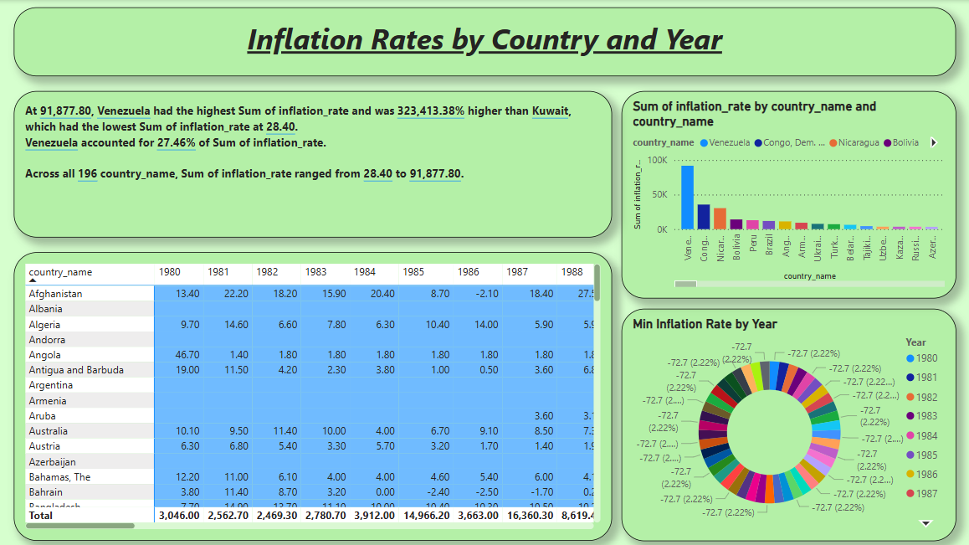

***Milestone-6: Performance Testing***

Performance testing is a critical component of software development aimed at evaluating the speed, responsiveness, and stability of an application under varying load conditions. By simulating real-world scenarios, such as heavy user traffic or high data volumes, performance testing helps identify potential bottlenecks, weaknesses, and areas for optimization within the system.

***Activity-1:*  Amount of data loaded:**

"Amount of Data Loaded" refers to the quantity or volume of data that has been imported, retrieved, or loaded into a system, software application, database, or any other data storage or processing environment. It's a measure of how much data has been successfully processed and made available for analysis, manipulation, or use within the system.



***Activity-2:*  Utilization of Filters:**

**1.Visual-Level Filters:**

•Apply filters that affect only a specific visual (e.g., chart, table).

•Go to a visual, and in the Visualizations pane, use the Filters section to drag and drop the field to filters.

**2.Page-Level Filters:**

•These filters affect all visuals on a specific page.

•To apply, go to the Filters pane, and under the Page-level filters section, drag and drop the field(s) to filter the entire page.

**3.Report-Level Filters:**

•These filters affect the entire report across all pages.

•Similar to page-level filters, apply these through the Filters pane under Report-level filters.

***Activity-2.1: Selected country Aland Island:***

To filter and visualize data specifically for **Åland Islands** in Power BI report, can follow these steps:

**1. Apply Filter for Åland Islands:**

* **Visual-Level Filter**: To filter a specific visual to display data only for Åland Islands:
  1. Select the visual (e.g., a chart or table).
  2. In the **Filters pane** under **Visual-level filters**, drag the field **Country_name** into the filter area.
  3. Select **Åland Islands** from the list of countries to filter the visual.
* **Page-Level Filter**: To filter the entire page for Åland Islands:
  1. In the **Filters pane** under **Page-level filters**, drag the **Country_name** field to the filter area.
  2. Choose **Åland Islands** as the selected country.
* **Report-Level Filter**: To apply the filter across the entire report (all pages):
  1. In the **Filters pane** under **Report-level filters**, drag **Country_name** to the filter area.
  2. Choose **Åland Islands** as the selected country.

**2. Create Visualizations Specific to Åland Islands:**

Once the filters are applied, any visualization (e.g., bar charts, line charts, cards, etc.) will only show data related to Åland Islands.

Examples of visualizations:

* **Line Chart**: Visualize inflation trends for Åland Islands over the years by adding **Year** on the X-axis and **Inflation_rate** on the Y-axis.
* **Gauge**: Show the current inflation rate for Åland Islands (e.g., 2024).
* **Bar Chart**: Compare inflation rates across different indicators (e.g., CPI, WPI) for Åland Islands.

**3. Add a Slicer for Country Selection:**

Dynamically choose **Åland Islands** (or other countries) from the report:

* Add a **Slicer** visual from the **Visualizations pane**.
* Drag **Country_name** to the slicer field.
* Now select **Åland Islands** from the slicer to filter the entire report.

This setup will enable to focus on the specific data for **Åland Islands** in your inflation analysis.

***Activity-3:*  No of calculation fields:**

***Activity-3.1: Conditional Column*:**

In Power BI can add conditional column summaries by creating calculated columns are measures that incorporate logical conditions based on data. These conditions can involve calculations like sum, Average ,etc., depending on the requirements. Once defined these calculated columns are measures dynamically summarize data based on the specified conditions, providing valuable insights into different subsets of data.

***Activity-3.1:* Average Inflation Rate**

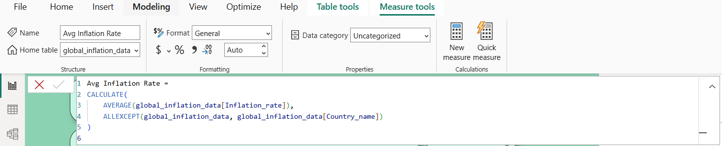

***Activity-3.2:* Max Inflation Rate**

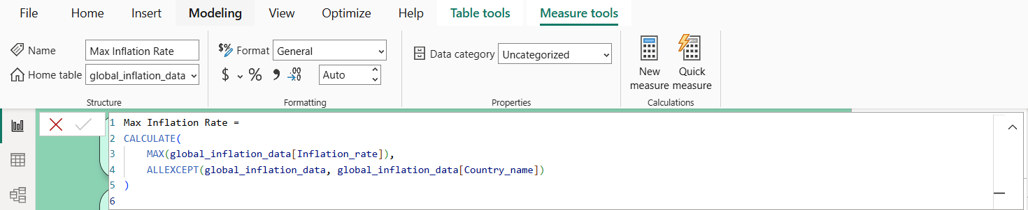

***Activity-3.3:* Min Inflation Rate**

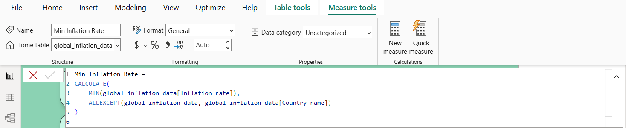

***Activity-3.2:* Target_Inflation Rate**

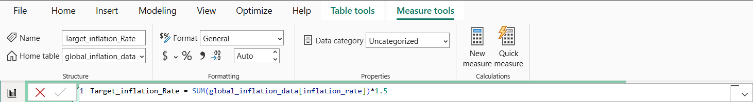

***Activity-4: No of Visualizations:***

1. Line Chart: Global Inflation Trends.

2. Stacked Bar Chart: Basic Inflation Rates by Year and Country.

3.Matrix Table: Country-wise Inflation Data.

4. Pie Chart: Inflation Rate Distribution per Year.

5. Area Chart: Cumulative Inflation Trends by Country.

6. Treemap: Inflation Rates Across Countries.

7. Decomposition Tree: Analyzing Factors Affecting Inflation.

8. Gauge: Sum of inflation rate by target value.

9.Cards:Min, Max, Avg inflation rate.

10.Filled Map: Analyzing map by country_name and Inflation_rate.

11.Donut chart: Minimum iflation rate by year.

12.Column chart: Analyzing column chart by inflation rate and country_name.

***Milestone 7: Project Demonstration & Documentation:***

**Activity 1: - Record explanation Video for the project's end-to-end solution**

**Video Link:** <https://drive.google.com/file/d/14nK9ZyM9xkoW8reObalo2jDH_rzFLrX9/view?usp=sharing>